

American International University-Bangladesh (AIUB)

**Faculty of Science and Technology (FST) Department of Computer Science (CS)**

**SDPM Group Project, Spring 2023 Project Title: Online Bus Ticket Booking System**

**Section: B**

**Submitted by**

|  |  |
| --- | --- |
| Name | ID |
| Hridoy Chandra Bir | 18-36841-1 |
| Rafid Redwan Khan | 20-42239-1 |
| Md. Shakibur Rahman | 20-42723-1 |
| Nur Mohammad | 20-42633-1 |

**1.0 Introduction:**

Recently, the practice of purchasing bus tickets online has become more widespread. An application that enables users or customers to check the bus ticket online is called the online bus ticket booking system. The system will be available for booking around-the-clock. The main benefit of doing so is saving money on bus tickets. Customers may make reservations at any time and from any location. Also, members occasionally receive offer codes to utilize for discounts. With the planned project, we have already begun by identifying the audience or target market. The individuals who will use the technology to purchase bus tickets online and those who would gain anything from it are the targets of this campaign. The management of bus ticket, booking, agent, and seat information is the system's primary goal. It controls all bus, passenger, seat, and bus information. People will be able to save time thanks to this system. If our objectives are met, consumers and users will have a reliable option for ordering bus tickets online and will receive the support they require.

# 2.0 Project Title:

“Online Bus Ticket Booking System”

# Objectives:

The goal of this project is to design and develop software that will automate crucial ticket booking activities, such as enabling online bus ticket purchases or any other procedures through a useful and user-friendly interface for the average bus passenger.

This project aims to,

* + - Create a web-based application called "Online Bus Ticket Purchasing System" to improve profits and reduce costs for passengers and bus companies.
    - Helping consumers purchase their tickets from the comfort of their homes and analyze the price structures of the routes, making it easier to schedule trips and preventing time conflicts.

# 4.0 Justification:

The online bus ticket booking system is a web-based application that runs on a central network. This project provides an overview of the software program 'Online Bus Ticket Reservation System' that should be used in a bus transport system. This is the functionality used for seat reservations, reservation cancellations, and various kinds of route queries used to secure faster reservations. Manage all customer data, bus data and

booking data. An online bus ticket booking system is definitely important as it helps people to book bus tickets and seats from anywhere. No need to physically go to the bus counter to reserve a seat or ticket on the bus. Instead, you can instantly book bus tickets and seats through our online platform. It's very easy to book online and get an overview of the whole process. However, the online system offers different types of offers on a monthly or daily basis, so that the customer can enjoy the services and benefits of the online ticket booking system.

# 5.0 Systems Overview:

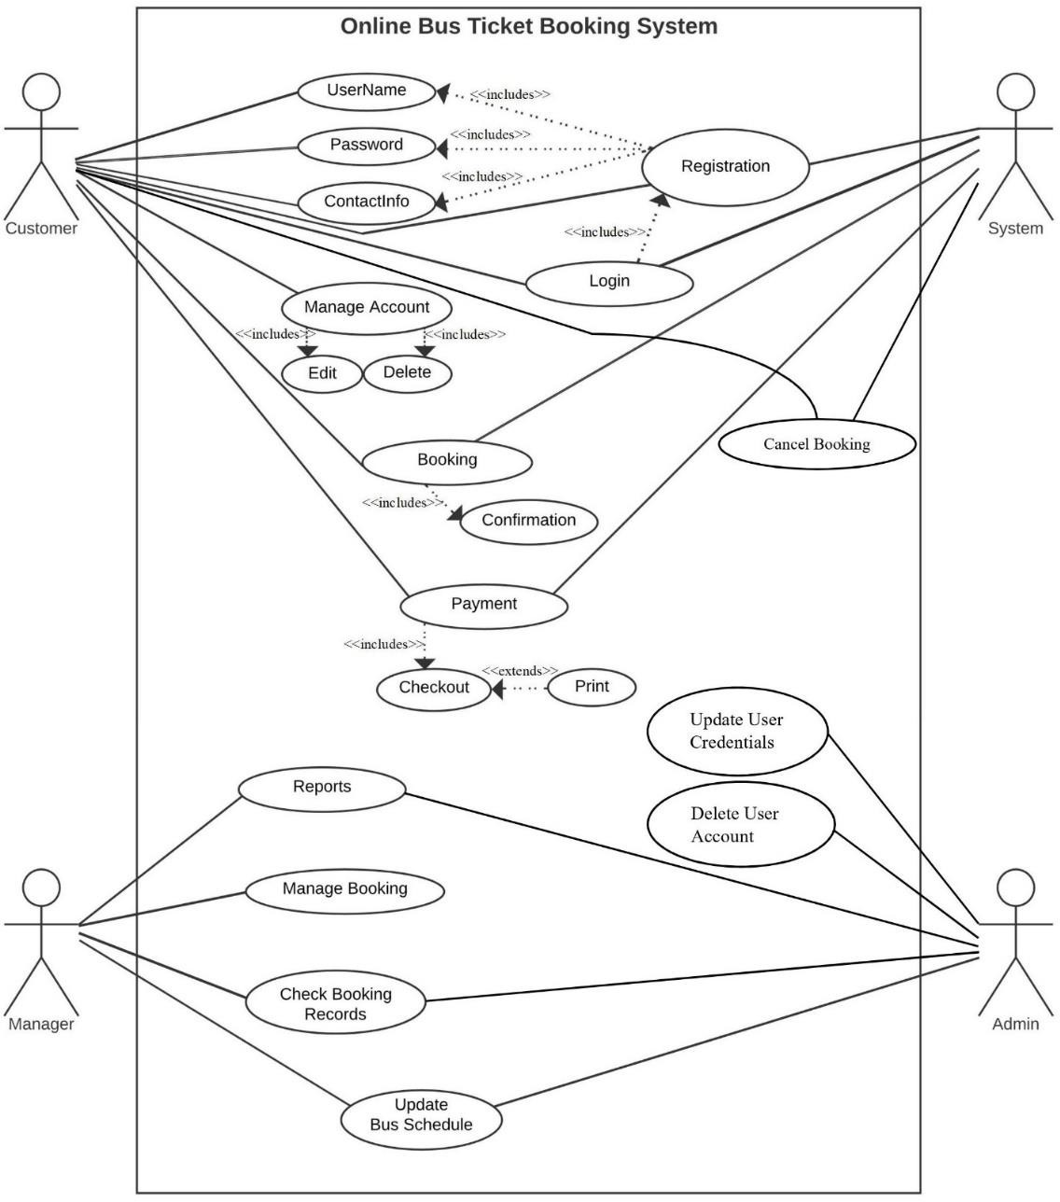

**6.0 Stakeholders analysis:**

Our system has two stakeholders named internal and external stakeholder.

## Internal Stakeholder

Employees, owners, shareholders, and managers are internal stakeholders. They could be anyone working at the company. internal stakeholder in our project will be,

## Employee

Internal stakeholders will primarily be employees. Because employees put a lot of time and money into the company, and because they are crucial to the organization's operations, strategy, and tactics.

## Developer

They are equipped with the technical know-how to advise executives on which features are practical and how long each would take to build.

## Manager

Managers are internal stakeholders because employees have a stake in the company's success because it affects their ability to get paid and keep their positions. Employees' attention to health and safety may also vary depending on the type of the company.

## External stakeholder

External stakeholders are individuals who are not affiliated with a firm directly but are nonetheless impacted in some way by its decisions and results.

## Suppliers

Suppliers give the components or raw materials that a business needs to make its products. A company may be dependent on a single supplier who creates a superior or uncommon good; in this instance, the supplier is of utmost significance.

## Government

A third-party stakeholder in every firm is the government. As a matter of fact, it is regarded as one of the key stakeholders because it collects taxes from these establishments in the form of corporate income tax and income tax from the firm's employees.

## Passenger

* The most significant external stakeholders might be regarded as the travelers. These are the individuals who will use the company's services or final products. Therefore, even if they are not involved in the day-to-day operations of the firm, they determine whether it will succeed or fail.

# Feasibility study:

In the feasibility study, the technical feasibility and financial feasibility are assessed to determine the viability of the project.

## Technical Feasibility:

Technical feasibility evaluates the technical aspects of the project and assesses whether the proposed system can be successfully implemented. In the context of your donation funding project, it would involve considering factors such as:

* + - Hardware and software components: This include assessing the availability and compatibility of the required hardware and software components needed for the system.
    - Technical risks and constraints: Identifying potential technical risks and limitations that may impact the implementation and operation of the system. This could include factors such as technological obsolescence, security risks, or scalability issues.
    - Compatibility with other IT systems: Assessing whether the proposed system can integrate smoothly with existing IT systems and infrastructure within the organization. Compatibility issues could hinder the successful implementation of the system.
    - Capabilities of the team: Evaluating the technical expertise and capabilities of the team responsible for developing and maintaining the system. It ensures that the team has the necessary skills and knowledge to handle the project effectively.

## Financial Feasibility:

Financial feasibility examines the economic viability of the project. It assesses whether the benefits derived from implementing the system outweigh the costs associated with its development and operation. In your case, since the system does not require any additional hardware or software, the focus would primarily be on the development costs versus the financial benefits. Key considerations would include:

* + - Development costs: Evaluating the expenses associated with designing, developing, and implementing the system. This includes costs for resources, such as personnel, equipment, and software licenses.
    - Financial benefits: Assessing the potential financial gains or cost savings that the system can bring to the organization. For example, in the context of a donation funding project, it could involve streamlining processes, reducing administrative overhead, or increasing donation revenue.
    - Cost-benefit analysis: Comparing the projected financial benefits against the development costs to determine if the investment is economically viable. The

benefits should equal or exceed the costs for the system to be considered financially feasible.

By conducting both technical and financial feasibility studies, organizations can make informed decisions about the viability of implementing a new system or modifying an existing one.

# Systems component:

The application will have three different sorts of users. They are,

* + 1. Customer (Passengers),
    2. Manager & stuff, and
    3. Admin.

These users can use the different components of the system application.

## Registration & Login

Users must create an account with specific details in order to use the bus ticket buying application. Users can connect to their accounts once the registration procedure is complete. Customers may get information about the bus schedules for various locations by login into their accounts.

Priority Level: High Pre-condition: N/A

## Manage Account

Account changes and deletions are available to customers. The information on the customer's account can be updated as needed.

Priority Level: Medium

Pre-condition: User must login first.

## Reservation / Booking

By comparing multiple bus timetables for various destinations, customers may purchase bus tickets. Customers have three payment options for purchasing tickets: mobile banking, card payments, and bank transfers. If a customer has any problems, they may also cancel their ticket. The reservation options are also accessible to the personnel. The personnel may also reserve tickets for guests using this application as a representative of the bus business. Managers are also in charge of the function for buying tickets.

Priority Level: High

Pre-condition: User must login first.

## Reports

Managers of bus companies will be able to report in advance the departure times for various bus destinations. They can also report any cancellations to the bus timetable due to unforeseen circumstances. The management of the bus business may also report any problems he encounters while using the system.

Priority Level: High

Pre-condition: User must login first and book a ticket.

## Manage Bookings

Only the management of the bus business may utilize this function. They may be able to reserve tickets for the travelers in some limited circumstances.

Priority Level: High

Pre-condition: User must login first.

## Check Booking Record

The management of the bus firm has access to the bus's booking history. Only managers have access to these functionalities. They are able to track the business's profit thanks to these characteristics.

Priority Level: High

Pre-condition: User must book more than 1 ticket to check the record.

## Update Bus Schedule

Only managers and admins are permitted to utilize this function. The bus's timetable can be updated by the bus company's managers. The bus timetable can also be updated by the admin. The bus timetable may be modified to suit their requirements.

Priority Level: High

Pre-condition: User must login first.

## Update Users Credentials

This feature can only be used by admin. Passengers' and customers' credentials can be updated by the admin. Customers' account details can be updated by the admin.

Priority Level: High Pre-condition: N/A

## Delete User Account

Only the admin may utilize this function. If the administrator notices the user's absence or any unrelated activity, the account may be deleted from the system.

Priority Level: Medium Pre-condition: N/A

# Process Model to be followed:

It appears that you have chosen to follow the Waterfall model for your project. The Waterfall model is a linear and sequential approach to software development where each phase follows the previous one in a downward fashion, similar to a waterfall. Based on the information you provided, here is a breakdown of the phases you plan to follow:

* + - **Stakeholder Analysis:** Identify and analyze the stakeholders involved in the project. Understanding their needs and expectations is crucial for project success.
    - **Feasibility Study:** Conduct a comprehensive analysis of the technical and financial feasibility of the project. This assessment helps determine if the project is viable and worth pursuing.
    - **User Requirements Gathering**: Collect and document the requirements of the system from the users. Properly capturing the user requirements is essential for building a system that meets their needs.
    - **System Design:** Perform an in-depth investigation of the system design. This phase involves creating architectural and high-level designs that serve as the blueprint for the system.
    - **Program Design**: Based on the system design, create detailed designs for the individual software components or modules. This step focuses on the internal structure and logic of the software.
    - **Coding:** Implement the designs from the previous phase by writing the actual code for the software system. This is the phase where the system is developed.
    - **Testing:** Thoroughly test the software system to identify any bugs or issues. If problems are found during testing, they are documented and addressed in the next phase.
    - **Bug Fixing:** If bugs or issues are identified during testing, necessary steps are taken to fix them. The software is reworked to address any problems and ensure its functionality.
    - **Operation:** Once the software is deemed stable and free of critical issues, it can be deployed and put into operation for users to utilize.

The Waterfall model emphasizes a sequential flow of phases, where each phase must be completed before moving on to the next. It is important to note that the Waterfall model assumes well-defined requirements and limited uncertainty. However, in real-world

projects, requirements can change, and uncertainty may arise. Therefore, it's crucial to remain flexible and adapt as necessary throughout the project lifecycle.

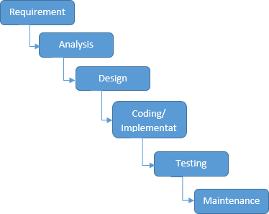

**Fig: The Development Life Cycle for Waterfall Model**

# 10.0 Efforts estimation:

The goal of our project is to create the “Online Bus Ticket Booking System”. We are assuming that the SLOC (Source Lines of Code) that we require here after analyzing all the components.

SLOC = 10,000

Now we need to figure out the effort, development time, and required number of people.

Suppose that, our software project type is organic, the values of the Coefficient<Effort Factor> =2.4

P = project complexity = 1.05 SLOC= 10,000

T= SLOC-dependent coefficient = 0.3 Now,

Effort = PM = Coefficient*(SLOC/1000) ^P PM = 2.4*(10000/1000) ^1.05

= 26.93

Development Time= DM= 2.5*(PM) ^T

= 2.5*(26.93) ^0.38

= 8.74

= 9 [In months] Required Number of People = ST

= PM/DM

= 26.93/8.74

= 3.08

= 3

# 11.0 Activity Network Diagram:

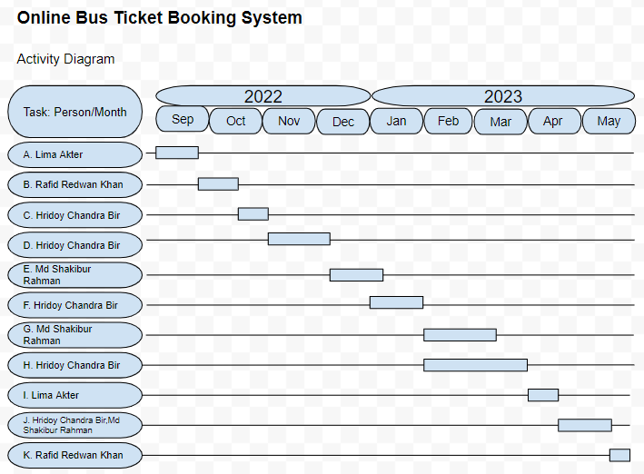

|  |  |  |  |  |
| --- | --- | --- | --- | --- |
| ACTIVITY KEY | ASSIGNED TO | START | END | Duration(day s) |
| A. Requirements Gathering | Lima Akter | 1 Sep 22 | 20 Sep 22 | 20 |
| B. Design and Analysis | Rafid Redwan Khan | 21 Sep 22 | 20 Oct 22 | 30 |
| C. Database Design and Implementation | Hridoy Chandra Bir | 21 Oct 22 | 10 Nov 22 | 21 |
| D. Backend Development-CRUD API | Hridoy Chandra Bir | 11 Nov 22 | 10 Dec 22 | 30 |
| E. Backend Development-MockAPI,Feature API | Md Shakibur Rahman | 11 Dec 22 | 10 Jan 23 | 31 |
| F. FrontEnd Development,Module Views | Hridoy Chandra Bir | 1 Jan 23 | 1 Feb 23 | 31 |
| G. FrontEnd Development,Admin Views and reports | Md Shakibur Rahman | 1 Feb 23 | 10 Mar 23 | 38 |
| H. FrontEnd Development,Customer and Employee Views | Hridoy Chandra Bir | 1 Feb 23 | 20 Mar 23 | 48 |
| I. Testing | Lima Akter | 21 Mar 23 | 10 Apr 23 | 21 |
| J. Bug Fixing | Hridoy,Shakibur | 11 Apr 23 | 20 May 23 | 30 |
| K. Development | Rafid Redwan Khan | 21 may 23 | 31 may 23 | 11 |

|  |  |  |
| --- | --- | --- |
| Activity Key | Precedents | Duration (Days) |
| A. Requirements Gathering |  | 20 |
| B. Design and Analysis | A | 30 |
| C. Database Design and Implementation | B | 21 |
| D. Backend Development-CRUD API | C | 30 |
| E. Backend Development-MockAPI,Feature API | C | 31 |
| F. FrontEnd Development,Module Views | B | 31 |
| G. FrontEnd Development,Admin Views and reports | D, E, F | 38 |
| H. FrontEnd Development,Customer and Employee Views | D, E, F | 48 |
| I. Testing | G, H | 21 |

|  |  |  |
| --- | --- | --- |
| J. Bug Fixing | I | 30 |
| K. Development | J | 11 |

**12.0 Risk Analysis:**

|  |  |  |  |  |
| --- | --- | --- | --- | --- |
| Risks | Category | Probability | Impact | RMMM |
| Size estimation significantly | PS | 30% | 2 | * Use multiple size estimation techniques to verify the estimation. * Software to be built or modified. |
| Business impact | BU | 20% | 2 | - associated with constraints imposed by market place. |
| Developer inexperienced | DE | 40% | 3 | - Define required experiences for the job clearly while recruiting. |
| Customer changes requirement at development stage | CU | 60% | 2 | * Communicate scope of changes and the change control policy clearly with the customer * Have a change control board |
| Technology stack gets deprecated | TE | 20% | 3 | * Use LTS versions where possible * Decouple as much as possible so replacements are possible. |
| Breaking changes in prebuilt packages | PR | 30% | 2 | * Prevent automatic updates to the repository modules and packages * Analyses each update before applying the updated version * Use a version control system |
| Staff size and experience | ST | 15% | 1 | * Communicate frequently * Secure early funding * Collect an upfront payment |

## Impact values

Catastrophic -1; Critical – 2; Marginal – 3; Negligible – 4

# 13.0 Budget for the project

Let’s say we have 8 months and need 3 developers to complete this project, Total Duration = 8*4weeks = 32 weeks

Working days (per week) = 5 days Working hours = 8 hours

So, Working hours (per week) = 5*8 hours = 40 hours Total Working hours = 32*40 hours = 1280 hours Developer’s Salary = 700 Taka/hour

Total Developer’s Salary = 700*1280 = 8,96,000 Taka

**Project Manager and his staffs’ salary:** Around 87,000 Taka

# 14.0 Conclusion:

Finally, we will receive user feedback following the completion of an entire project module. Online ticket and management should be guaranteed by a software-based bus ticket management system. This project will include customer iteration; therefore, project management must properly measure, objectively differentiate, and assign tasks. The hardest part of this project is staying on track and completing the work on time given the overall project deadline of 5–10 months. People today are yearning for online systems. Considering that it is the easiest and most practical means of getting information. There are several online ticketing companies in Bangladesh. Our system is meant to be a web- based application that includes customer-required services. Not only will it benefit customers, but also owners and bus owners.

…